**Business Problem**

In recent years, City hotels and Resort hotels have seen high cancellation rates. Each hotel is now dealing with a number of issues as a result, including fewer revenues and less hotel room use. So, analyse the data of hotel bookings and extract actionable insights which can reduce the cancellation rates. Also, provide business inputs which can increase the overall revenue.

Key Objectives

1. Understand the effect of different variables on booking cancellations.
2. Explore the demographic characteristics of hotel guests to tailor marketing strategies and improve their experience.
3. Identify the reason for high cancellation rates by providing the insights of the analysis.

**Assumptions**

1. No unusual occurrences between 2015 and 2017 will have substantial impact on the data used.
2. The information is updated and can be used to analyse a hotel’s possible plans.
3. The biggest factor affecting revenue is booking cancellations.
4. Clients make hotel cancellations the same year they make reservations.
5. Cancellations result in vacant room for the booked length of time.

**Analysis and Findings**

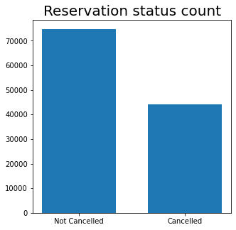

The above graph shows that the cancellation rates are almost 50% when compared to the rooms which are not cancelled. To be more exact the cancellations are 37.1% and the rooms that are not cancelled are 62.8%.

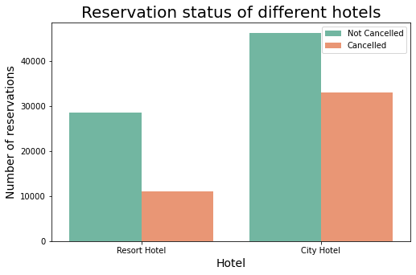

The above graph tells that the percentage of cancellations are high in City hotels when compared to Resort hotels. The cancellation of Resort hotels are 27.9% and that of City hotels are 41.7%. The hotel bookings are more in City hotels but the cancellation rates are also very high in these hotels. As the Resort hotels are booked very less compared to city hotels, it’s possible that the price of the Resort hotels are more than City hotels.

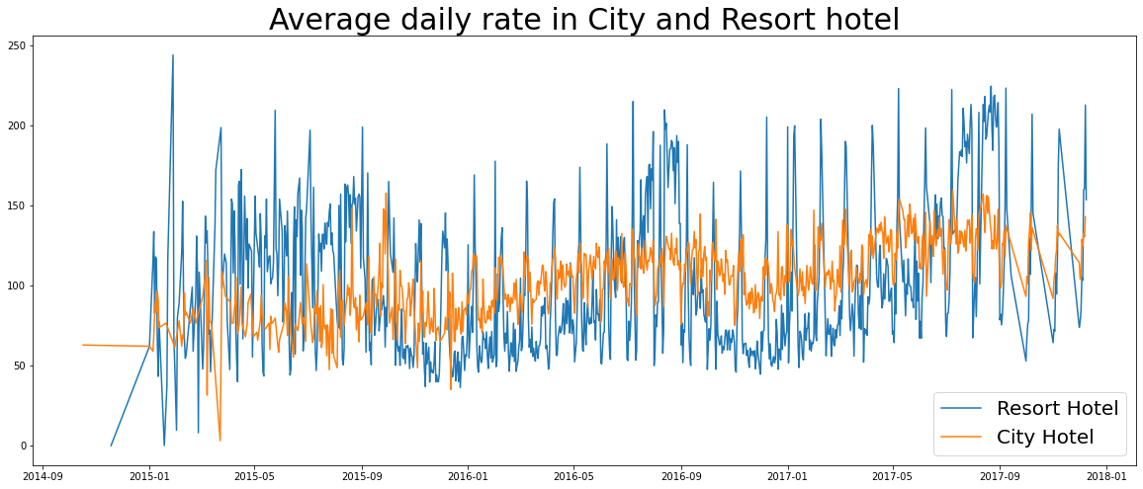

The above line graph shows that, on most days the average daily rate of City hotels is less than the Resort hotels, even on the weekends or holidays. The spikes in the graph shows the price on the weekends and holidays.

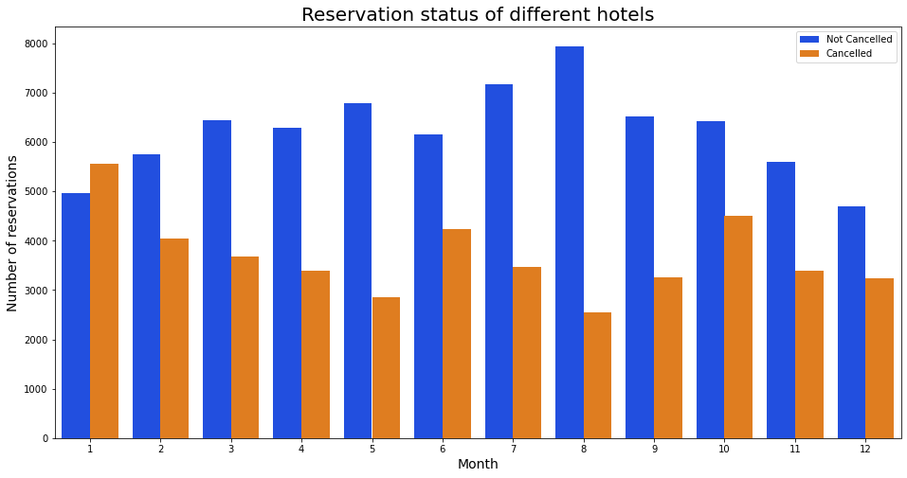

When analysing the months with the highest and the lowest reservation levels, it is observed that in the month of August, the number of confirmed reservations are highest and the number of cancelled reservations are lowest, while the month of January has the highest number of cancellations.

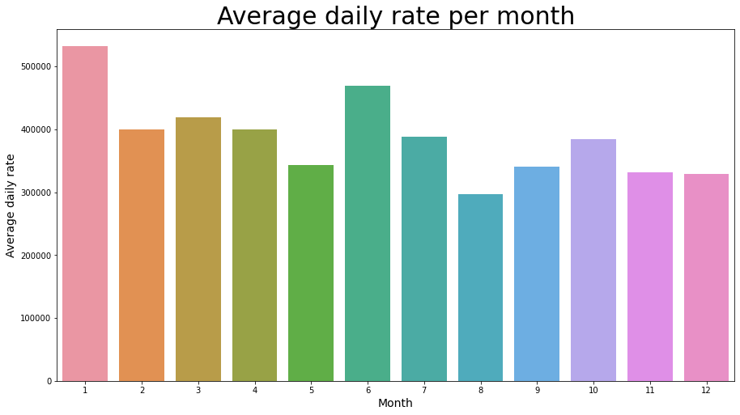

The above bar graph demonstrates that the prices are higher in January and the prices are less in August. Also, it is known that the cancellations are more in January and the cancellations are less in August. This proves that the cost of the hotel rooms are affecting the cancellation rates, as the cancellations are highest in January when the rates are also the highest and the cancellation rates are the least in August when the rates are the least.

Now let’s see which country has the highest cancellation rates

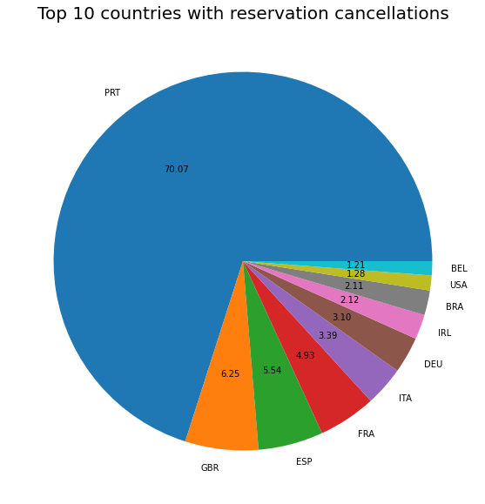

It is observed from the above chart that 70% of the cancellations are from Portugal which is very huge and the rest of the countries are making good business as the cancellation rates are quite low.

It is also seen that online TA bring most of the reservations which is 46.9% , 27.3% come from groups, 18.7% come from offline TA/TO and only 4% come from the direct source.

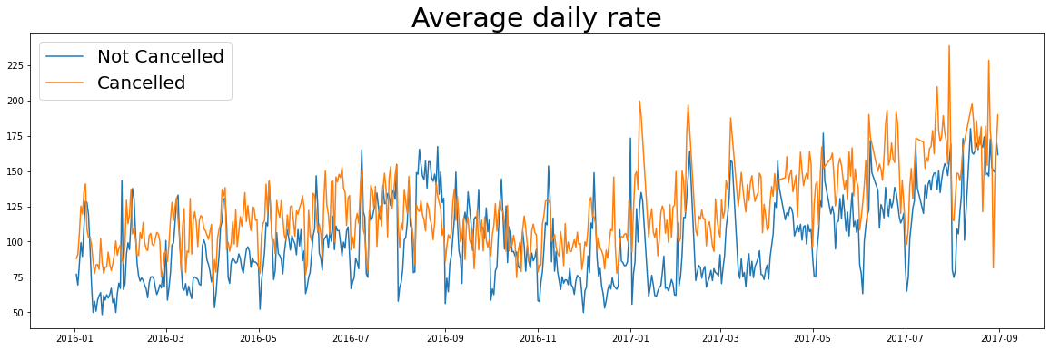

It is seen from the graph that the cancellations are higher when the rates are higher. From the above analysis it is clear that higher price is leading to higher cancellations. So it is important to lower the price to an optimized value.

**Suggestions**

1. Cancellation rates rise as the price does. In order to prevent cancellations hotels can lower the price to an optimized value and also work on the pricing strategies. Discounting is also a good strategy.
2. As the cancellations are high City hotels, customer experience should be improved and marketing strategies should be adopted to retain the guests once they book a reservation.
3. The year starts with January month and the same has huge cancellations. It’s a good business strategy to reduce the price when the year starts and attract the guests, give them a good hotel experience and then retain those costumers based on the value which has been provided. Also, hotels can think of offers in the starting month.
4. The problem for huge cancellations in Portugal has to sorted out as soon as possible. Check if the services, hospitality, maintenance are up to the mark.
5. Collect feedback regarding the guests experience in the hotel. It helps in evaluating and analysing the performance better and understand the customer better.